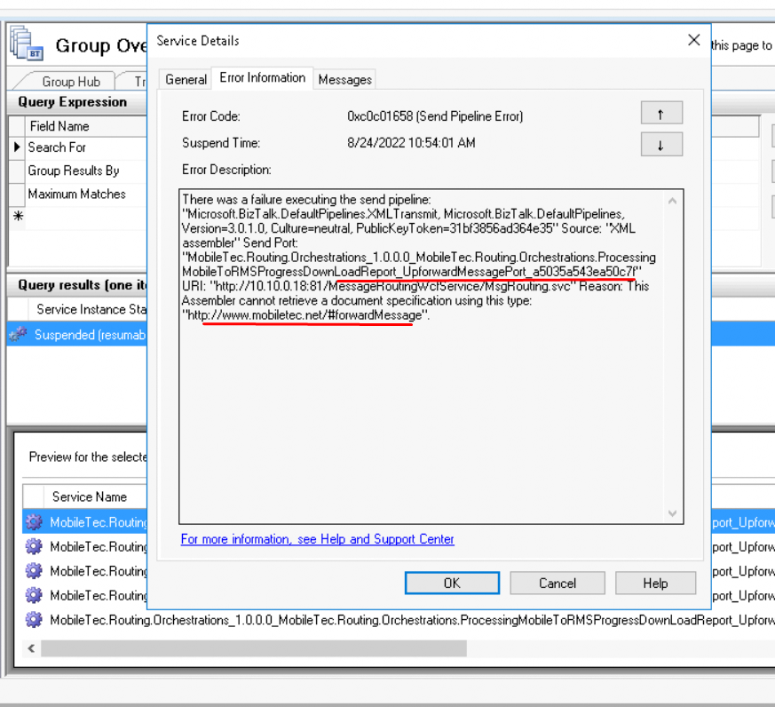

MobileTec.Routing.Orchestrations_1.0.0.0_MobileTec.Routing.Orchestrations.ProcessingMobileToRMSProgressDownLoadReport_UpforwardMessagePort_a5035a543ea50c7f

